**Installation of a new artificial cricket wicket.**

Frensham Parish Council would like to advise that we are supporting a proposal from Frensham Cricket Club to install an artificial cricket wicket on the second square on Hollowdene Recreation Ground for the new season commencing April 2025.

The rationale for such a proposal is to allow the Club to utilise the pitch in all weathers so investing in our facilities and creating a sustainable future for our cricket ground. Additionally, this allows the Cricket Club to reduce the number of pitches required. This is in-line with a number of other villages that have already installed an artificial pitch.

The new pitch will be 30m long and 2.74m wide and in the same colour as the natural square. Excavation of the site would look to commence week commencing 24th April 2025 and will take two days to excavate and install the astro turf. This will then require two weeks to settle during which time the wicket will be secured with orange safety tape.

Below is a picture of another ground that has utilised the same material.

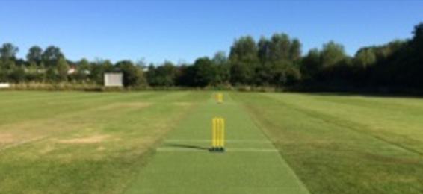

A planning application will be submitted to Waverley sometime late October and can be found on <https://www.waverley.gov.uk/Services/Planning-and-building/View-and-comment-on-planning-applications/Search-planning-applications>

If you have any questions, the Council are inviting you to submit these directly to the Clerk in person or via email. [clerk@frensham-pc.gov.uk](mailto:clerk@frensham-pc.gov.uk) The office is open Wednesday and Thursday 10am to 3pm.

Any questions will be collated and a Q&A session with both the Council and the Cricket Club will commence at the meeting of the Council on 15th January 2025 of which residents are encouraged to attend.