On Sunday 3rd November at 10am Frensham Parish Council are installing the bug hotel on the lower East facing edge of the small copse so that there is open access to light and sun from the front but sufficiently tucked into the edge of the vegetation to give shelter too.

Please come along and help if you can, spread the word & especially encourage any youngsters to come and help assemble (moss and sticks can be added by small hands over the coming weeks if you are passing the common).

Below is a sample bug hotel we would like to recreate. If you have any suitable materials, please do feel free to bring these with you. For example.

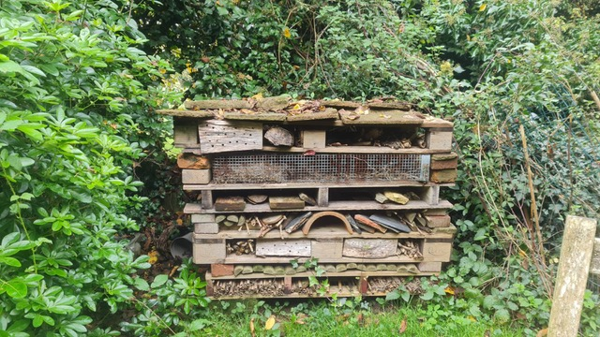

* bundles of twigs,
* bamboo canes short enough to fit,
* broken terracotta/slate tiles
* hollow stems - stinging nettles stalks
* small logs

We look forward to seeing you there, however if you have any questions please do contact the Clerk, [clerk@frensham-pc.gov.uk](mailto:clerk@frensham-pc.gov.uk) or Councillor Scimone, [Fiona.scimone@frensham-pc.gov.uk](mailto:Fiona.scimone@frensham-pc.gov.uk).