You may have noticed the poor condition of the existing ramp. The Ramps underlying structure is failing throughout and the wooden posts have rotted. This has been patched up over the years, but the new councillors believe the time has come for the ramp to be rebuilt in order to provide a long term robust feature to our much used and loved recreation ground.

Here are some picture of the progress and we shall continue to update them throughout until completion.

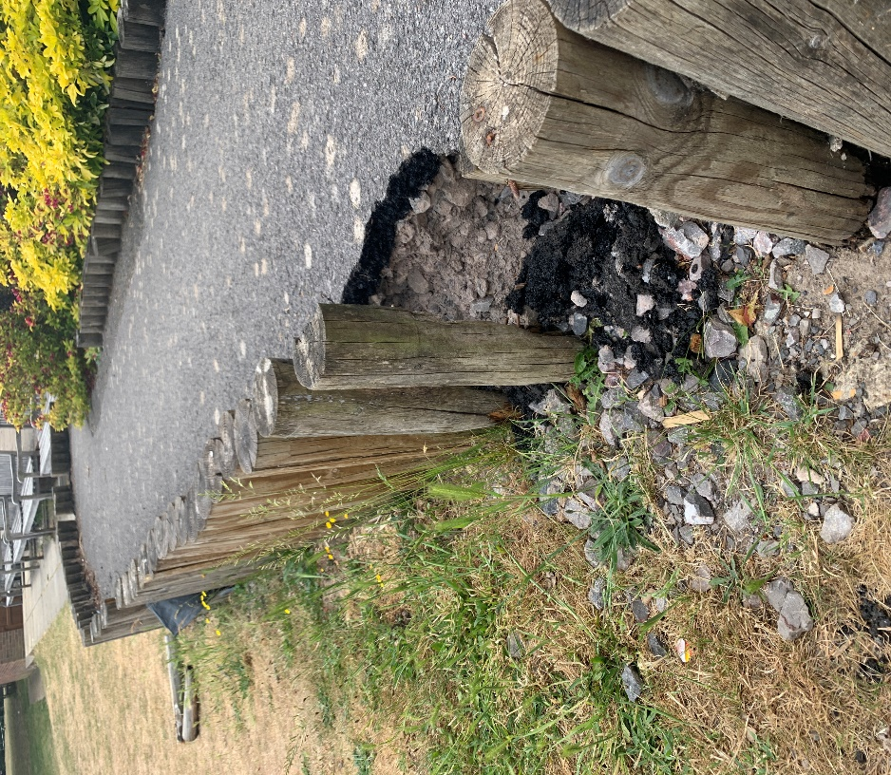 | 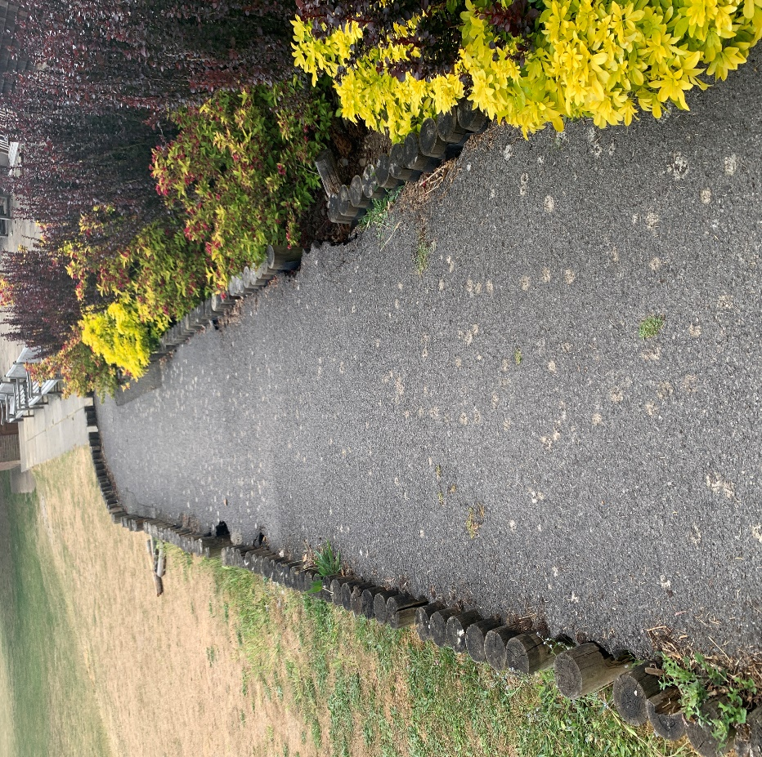
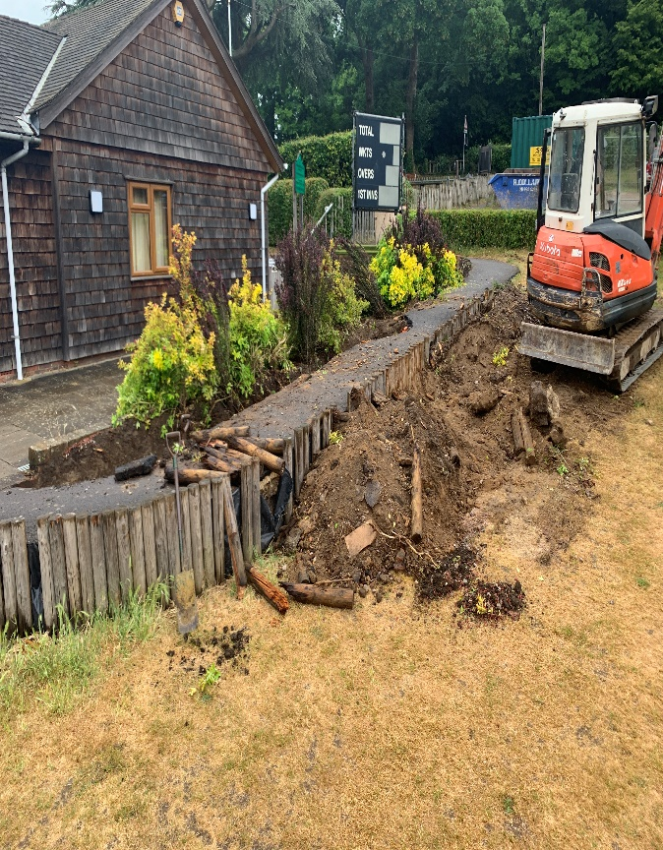 | 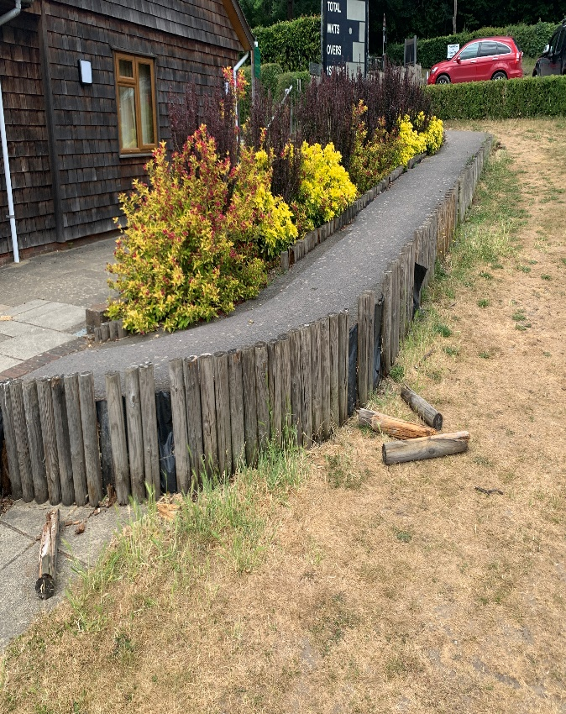
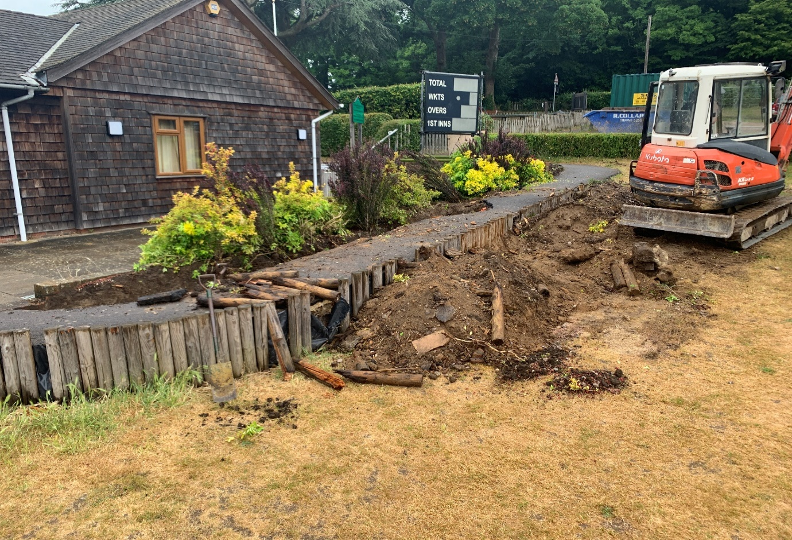 | 